**Steps to Generate Swagger Documentation**

1. Add the following dependencies in pom.xml
   1. springfox-swagger2
   2. springfox-swagger-ui
2. Add a class like SwaggerConfig and annotate with @Configuration and @EnableSwagger2 at the class level (See the screenshot in step 3)
3. Write a bean method and return the object with Docket return type from springfox dependency.

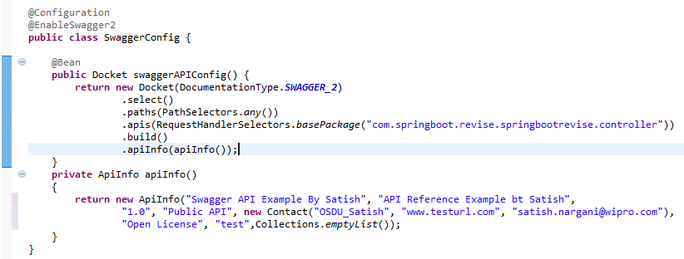

1. Need to add the controller base path for scanning all the apis from the spring boot application
2. Start the server and hit the url like swagger-ui.html

Eg: <http://localhost:8080/swagger-ui.html>

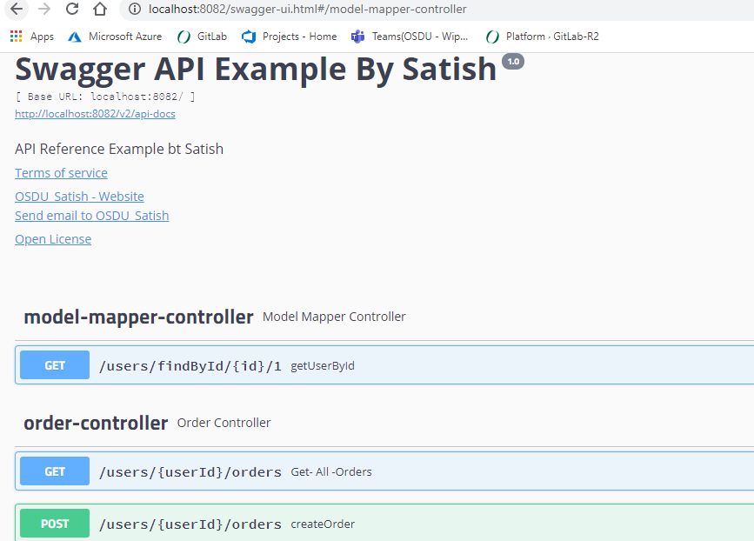

**Steps to Generate Swagger open api spec Yaml file in case swagger is enabled**

1. **Add the maven dependency with artefact** springdoc-openapi-ui **in the pom.xml**
2. **Run the service and open the url -** [**http://localhost:8082/v2/api-docs**](http://localhost:8082/v2/api-docs)
3. You should see the json file in the browser

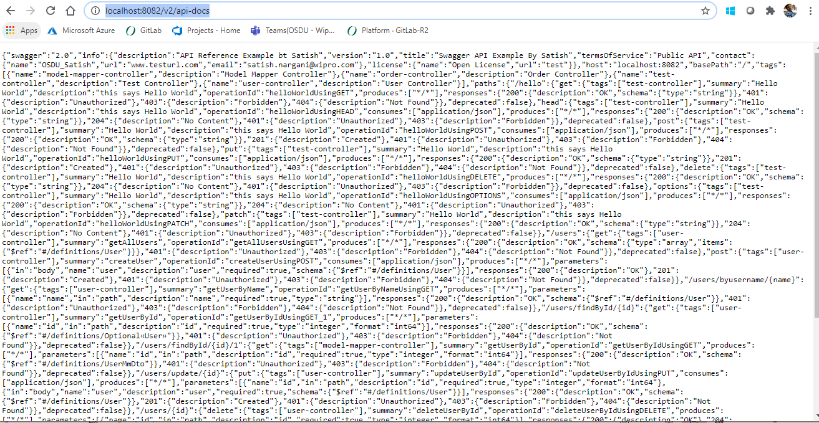

1. Open the link <https://editor.swagger.io/> and paste the content of json from step3

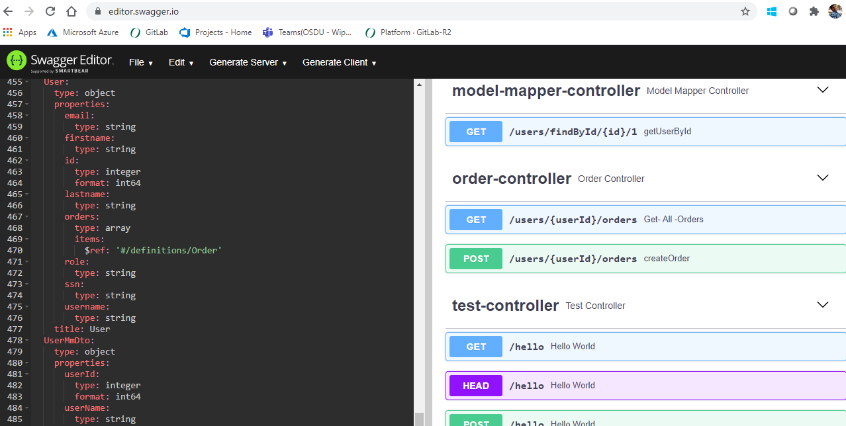

1. Copy the yaml generated on the left side of the panel and it is the open api spec